

Parikshit Task -1
Git and Github

BY
VIDYA NAYAK
251090050032

Index
Sl. No. | Contents | Page No.
1 | Basic Windows Commands | 3
2 | Versioning | 4
3 | Version Control System and types | 6
4 | Introduction to Git and Git commands | 8
5 | Github account setup and creating repository | 14

Basic Windows Commands
1. mkdir foldername – to create a new folder
2.ls – to list all files/directories
3.clear – to clear the screen
4.cd foldername – to open a folder listed in ls
5.cd .. – to come out of a folder
6.cat filename.extension – to read a file
7.echo "Hello I am Vidya" > vidya.txt – create a file
8.notepad filename.txt – to edit the contents of a file

Versioning
Versioning is a process of tracking changes to a product over time.
Each time you make changes, Git saves a new version.
Real Example
If you are making a hotel prediction website:
- Initially only backend – Version 1
- Login page added – Version 2
- Payment option added – Version 3
Git tracks all these versions.
Why Versioning is Important?
1. Undo Changes
If your new code breaks, versioning helps to recover the older version.
This helps us to experiment freely.
2. Track Progress
Git helps us track:
- Who made the change
- What changes were made
- When the changes were made
3. Team Collaboration
Different people can work on:
- Frontend
- Backend
- Login Page
without disturbing each other.
4. Professional Project Management
All software companies use version control.
Challenges Before Versioning
- Tracking changes becomes very difficult.
- Recovering old versions is not easy.
- Collaboration becomes confusing.

Version Control System
A Version Control System is a tool that helps you track changes to documents, code, and files over time.
A Version Control System helps to:
- Track changes
- Save project history
- Collaborate safely
A VCS records changes over time.
Example Without VCS
- parikshit_project_latest
- parikshit_project_final
- parikshit_conclusion
This becomes very confusing because multiple copies of files are created.
With VCS
Version 1
↓
Version 2
↓
Version 3
All changes are tracked properly.
Benefits of VCS
- Experiment freely
- Disaster recovery
- Parallel development
- Accountability
- History of changes
Problems Before VCS
- Error-prone
- Conflicts
- Slow development

Introduction to GIT
Git is a distributed Version Control System (VCS) used to track changes in files and source code over time. It helps developers manage projects efficiently, maintain a complete history of changes, and collaborate with others without overwriting each other's work.
Git was created by Linus Torvalds in 2005 for the development of the Linux kernel. Today, it is the most widely used version control system in software development.
GIT Commands
Installing Git on Computer
1. Initialize a Repository
git init
Creates a new Git repository in a folder.
2. View Branches
git branch
Shows the branches present in the Git repository.
3. Check Repository Status
git status
Shows the branch and commit history/status.
4. Add File to Staging Area
git add filename.txt
Moves the file to the staging area.
5. Commit Changes
git commit -m "Added"
Permanently creates a snapshot of the project.
6. Switch Branch
git checkout feature1
Switches to the feature1 branch.
7. Create a New Branch
git branch feature1
Creates a new branch called feature1.
8. View Commit History
git log --oneline
Shows the commit history in a compact form.
9. Configure Username and Email
git config --global user.name "Vidya"
git config --global user.email "vidya@gmail.com"
Used to set up your Git username and email.
10. Remove a File
git rm filename.txt
Removes the file from the folder and Git tracking.
Understanding git diff
Step 1
cd git-parikshit
Step 2
echo "Hello I am Vidya" > hello.txt
Step 3
git add hello.txt
git commit -m "Added Hello"
Step 4
notepad hello.txt
Make some changes and save.
Step 5
git diff
git diff shows the changes made in a file before committing them.
12. Rename a File
git mv oldname.txt newname.txt
Used to rename a file.
13. Store All Text Files Inside a Folder
mkdir textfolder
mv *.txt textfolder
mv can also be used to move files.
14. Create a Tag
git tag tagname
Creates a new tag.
15. List All Tags
git tag
Lists all tags.
Pushing a Local Repository to GitHub
Step 1
Create a repository named git-parikshit on GitHub.
Step 2
git remote add origin <repository-url>
git push -u origin main
Pushes the local repository to GitHub.
Pulling Changes
git pull origin main
Downloads and merges changes from GitHub to the local repository.
Branching and Merging
Fast Forward Merge
When:
- Main branch is stable
- Feature branch moves forward
Step 1
git branch feature1
Create a new branch.
Step 2
git checkout feature1
Switch to the branch.
Step 3
echo "Vidya Nayak" > vidya.txt
git add vidya.txt
git commit -m "Added Hello"
Step 4
git checkout main
Step 5
git merge feature1
Three-Way Merge
Both branches have moved forward.
Step 1
git checkout feature1
Step 2
echo "This is feature1" > feature.txt
git add feature.txt
git commit -m "Added feature"
Step 3
git checkout main
echo "Vidya Nayak" > intro.txt
git add intro.txt
git commit -m "Intro"
Step 4
git merge feature1
This may create a merge commit (or merge conflicts if both branches modify the same lines).
Understanding .gitignore
Step 1
mkdir temp
Step 2
cd temp
echo "Do not track it" > temp.txt
Step 3
notepad .gitignore
Inside .gitignore:
temp/
This tells Git not to track the temp folder.
Restore
git restore --staged unstages a staged file.
Step 1
cd parikshit-git
Step 2
echo "Hi I am Vidya" > i.txt
git add i.txt
Step 3
git restore --staged i.txt
Help Command
Displays documentation and help.
git config --help
Opens the help page for the git config command

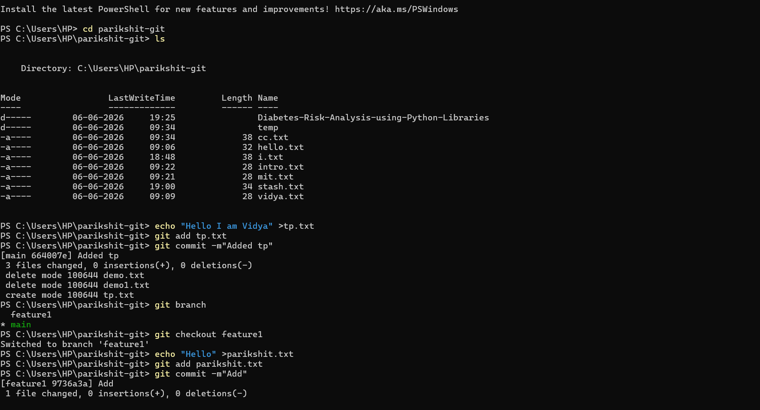
Figure 1:Image of demonstrating git commands
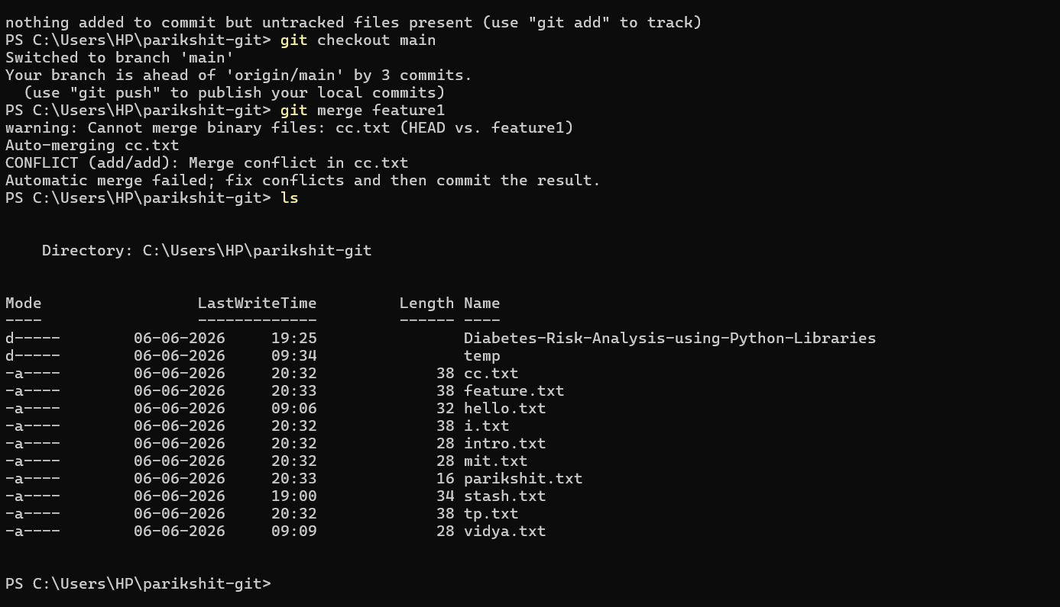
Figure 2:Image of demonstrating git commands

GitHub Account Setup and Creating a Repository
Part 1: Create a GitHub Account
Step 1
Open your browser and go to:
GitHub Official Website
Step 2
Click Sign Up.
Step 3
Enter:
- Email address
- Password
- Username
Step 4
Complete the verification process.
Step 5
Click Create Account.
Step 6
Verify your email using the verification link sent to your inbox.
Your GitHub account is now ready.
Part 2: Create a New Repository
Step 1
Log in to GitHub.
Step 2
Click the "+" icon in the top-right corner.
Step 3
Select New Repository.
Step 4
Enter the repository name.
Step 5
Choose repository visibility:
- Public
- Private
Step 6
(Optional) Select:
- Add README file
- Add .gitignore
- Choose License
Step 7
Click Create Repository.
The repository is now created on GitHub.

MY Repository Link

VidyaNayak02/Parikshit-taskphase

